Visual Story

A visit to WXYZ Studios: step-free entrance to dance studios.

WXYZ Studios is a red brick building in North Melbourne. Inside are two dance studios and an office.

The step-free entrance to the studios is located at 41 Little Dryburgh Street South.
There is also step-free entrance to the LGI office only at 130 Dryburgh Street (via a temporary ramp).

This is WXYZ Studios seen from Little Dryburgh Street South.
The white door may be open or closed when you arrive.

To get from the street to the door there are cobblestones and a small curb cut.
You can request a temporary ramp to get over the curb cut. Simply call us on 03 9329 4213 and we’ll bring it out.
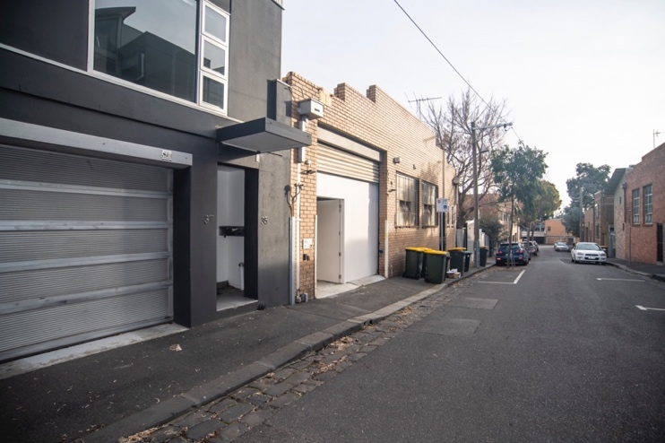
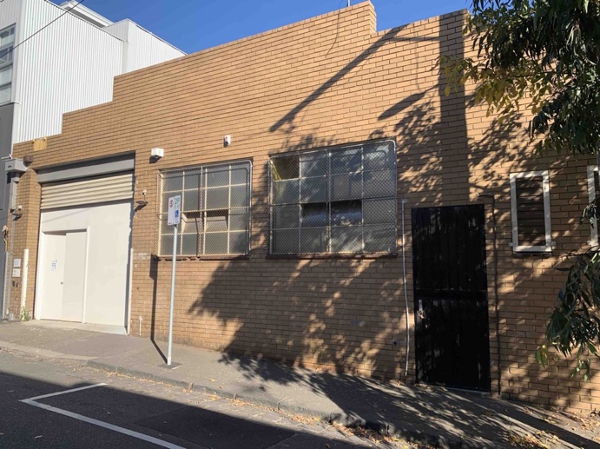

This is the intercom (left) and the keypad (right).
To use the intercom, press the black button to speak to the LGI office
Use the keypad to enter your access code if you have one — such as 1234*

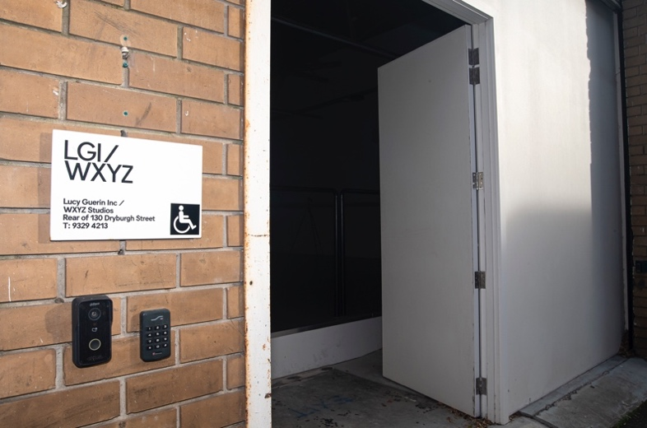

This is the ramp into Studio Two inside the door.
The ramp gradient is 1:12.

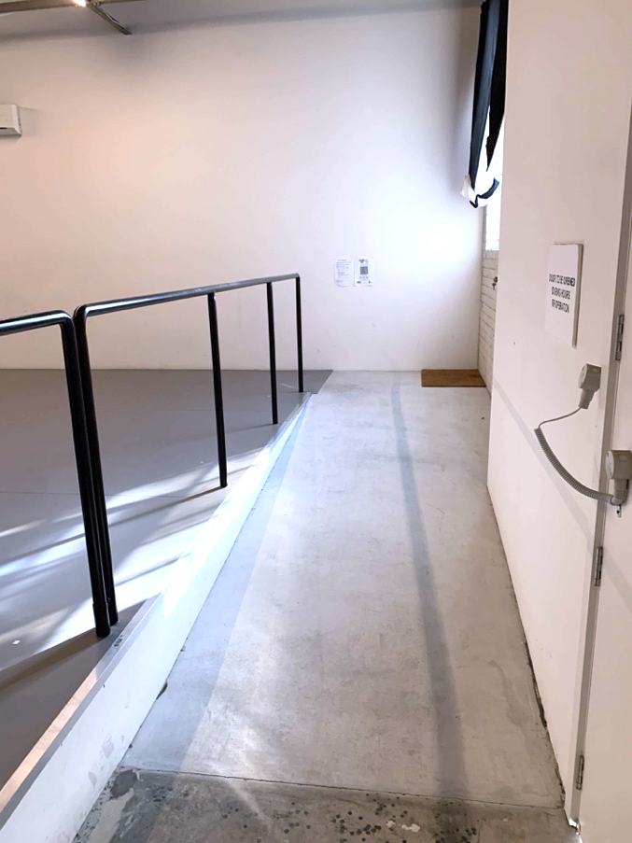

This is the view of Studio Two from the top of the ramp. It is the smaller studio.
The white doors lead into Studio One and the other facilities.

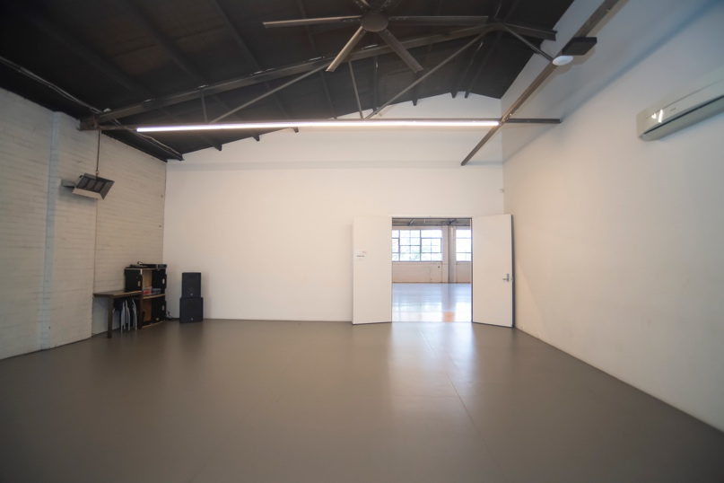

This is the view of Studio One from Studio Two.
Studio One is the larger studio.

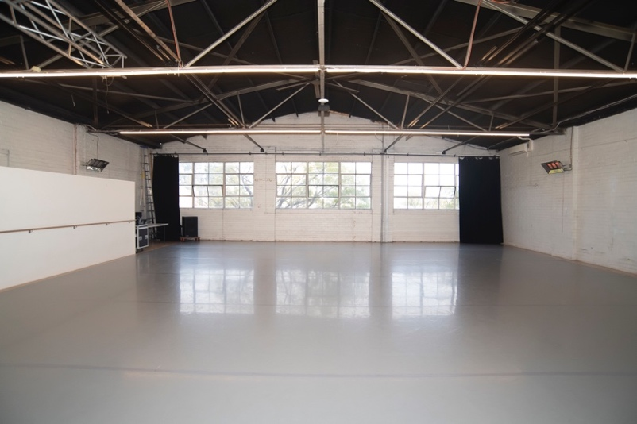

The black drapes into Studio One may be open or closed. If they are closed it looks like this.

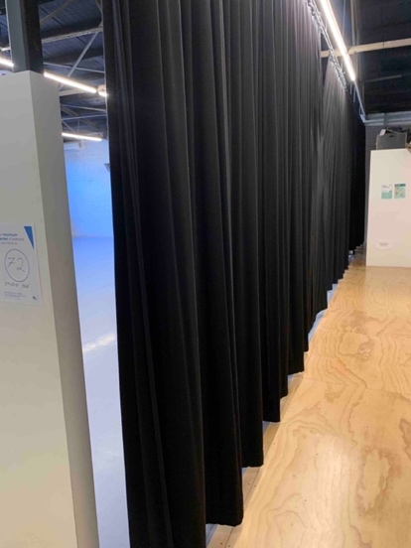

Turning left from Studio Two leads to the top of the stairs.
These stairs lead to the LGI office and the exit onto Dryburgh St.

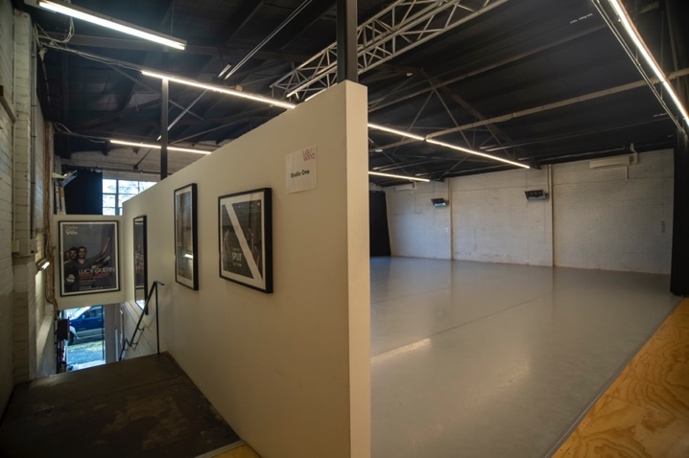
Turning right from Studio Two is the kitchen. This is the view into the kitchen from the door.

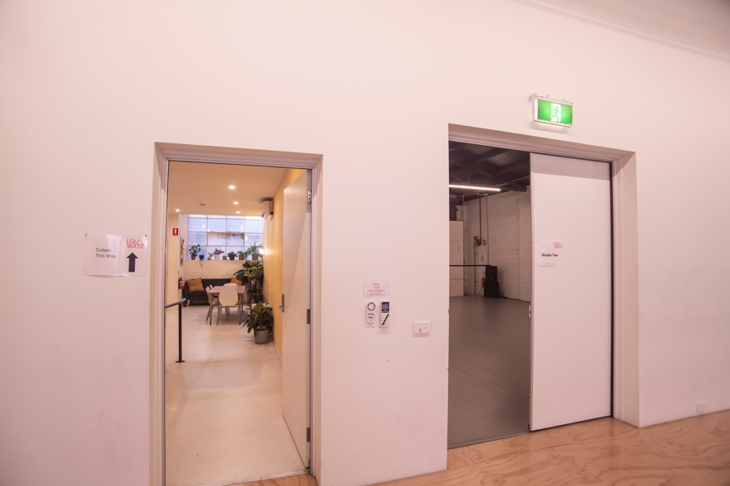

This is the kitchen. There is a large fridge, dishwasher, sink with taps, coffee machine, kettle and microwave.

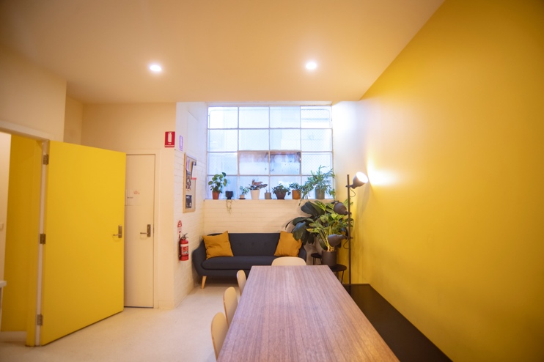

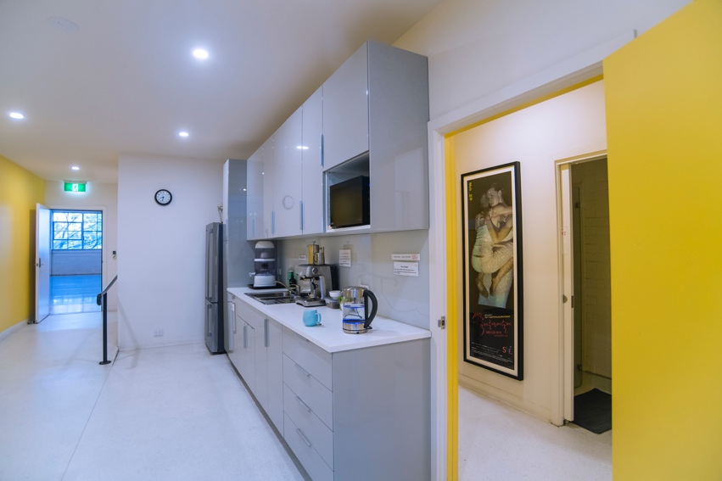
The changing rooms and bathrooms are next to the kitchen.
There are hooks to hang clothes and pigeonholes and lockers where you can put your things.
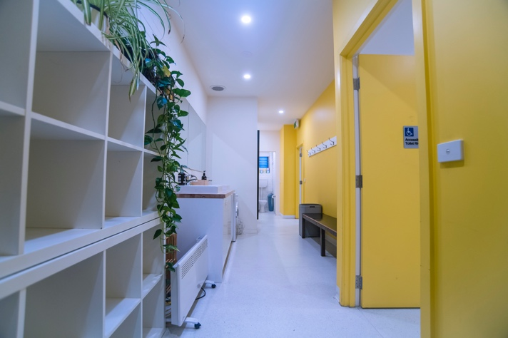
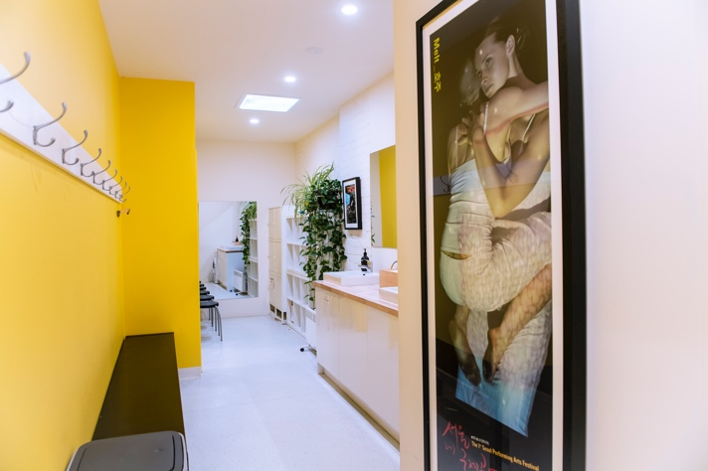
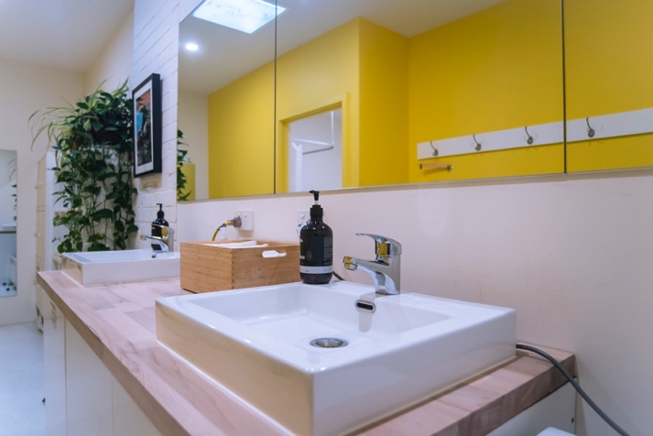
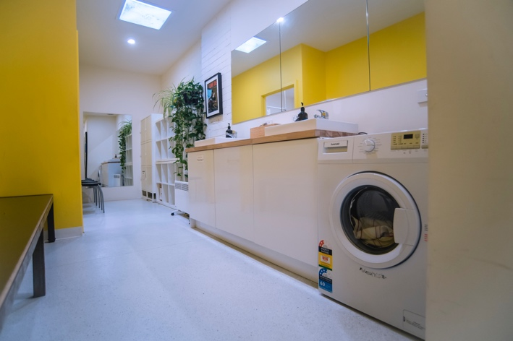
These are the doors to two toilets.
The one on the left has a handrail inside.

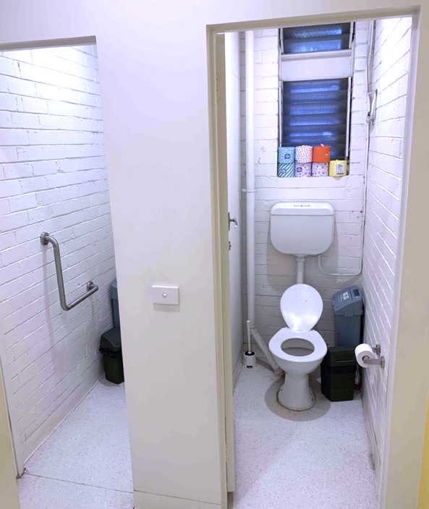
This is the door to the accessible bathroom.

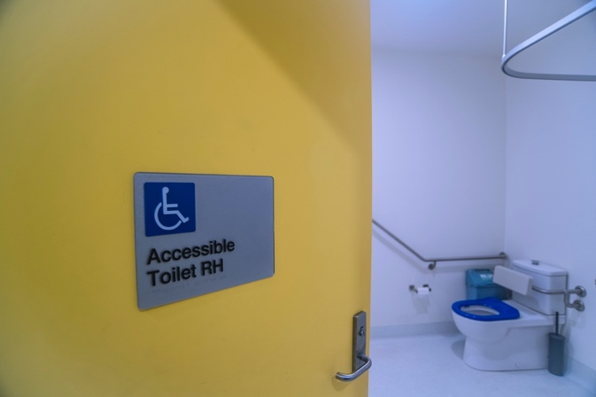

The accessible bathroom has a RH toilet with handrail, a shower with fold-down bench and a sink with lever-handled tap.
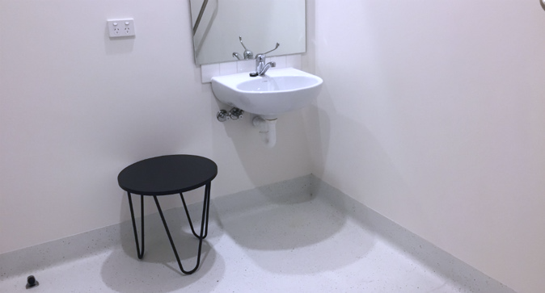
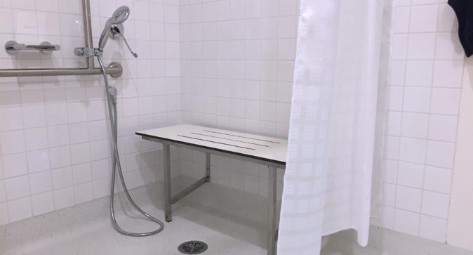
At the end of your visit, you may leave via the same door you entered, in Studio Two.
Push the door handle down to exit onto Little Dryburgh Street South.

