WXYZ Studios
Accessibility Guide
LGI seek to make WXYZ Studios a venue that’s accessible for as many people as possible. To support this, we have a range of facilities in place to support broad access:

- Step-free entrance to WXYZ Studios is at 41 Little Dryburgh Street South.
  - This entrance has level access and an internal ramp into Studio 2.
  - Ramp gradient 1:12.
  - Access code keypad/intercom at this entrance are 90cm above the ground.
  - There is a small curb cut of 5cm and three rows of cobblestones connecting the road to the pavement.
  - Please note that our office entrance on 130 Dryburgh Street has a single step and keypad / intercom positioned 1.5m above the ground.

- Step-free entrance to office only is at 130 Dryburgh Street via a temporary ramp.

- Level access throughout the top floor. This links the step-free entrance to the two dance studios, kitchen, changing rooms and bathroom. There is a total of 16 stairs connecting the Dryburgh Street entrance and LGI office with the studios.

- An accessible bathroom with a lockable door, containing:
  - One RH toilet with handrail plus a lowered basin with a levered tap.
  - One shower with adjustable shower head and levered handle with a fold-down bench and wrap-around shower curtain.
  - One small table for possessions.

- Theatre drapes that can be closed across the windows in both studio spaces to create lower stimulation environments.
  - In Studio One, there are additional drapes that can be closed across the studio corridor to make Studio One a more private space and reduce distractions.

- Lighting in both studio spaces is currently limited to overhead strip lights, or natural light during daytime.
- All bathroom and changeroom facilities at WXYZ Studios are all gendered.

Facilities that WXYZ Studios does not currently provide

- A dedicated quiet space. If this is needed for your activity, please discuss options with us in advance of your visit.
- Tactile indicators.
- A hearing induction loop.
- Braille signage.
- In-house interpreters.

Parking Space for disability badge holders

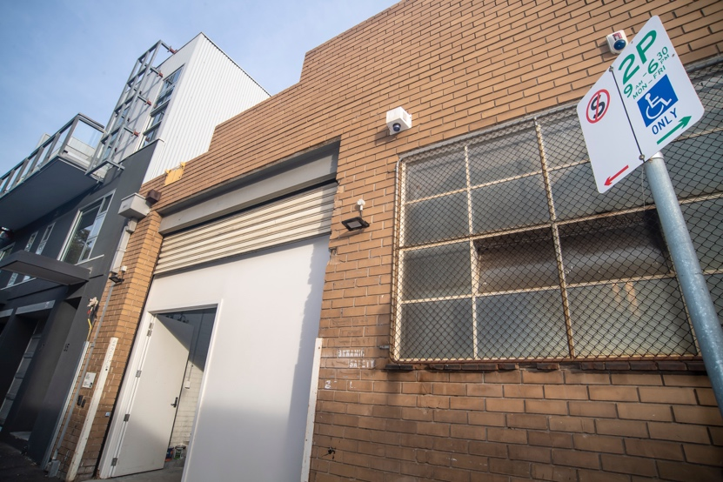
- Space is located at 41 Little Dryburgh Street South, adjacent to the studios’ wheelchair accessible entrance (white doors in image below).

- Text on the sign reads: 2P 9am - 6:30pm MON-FRI.

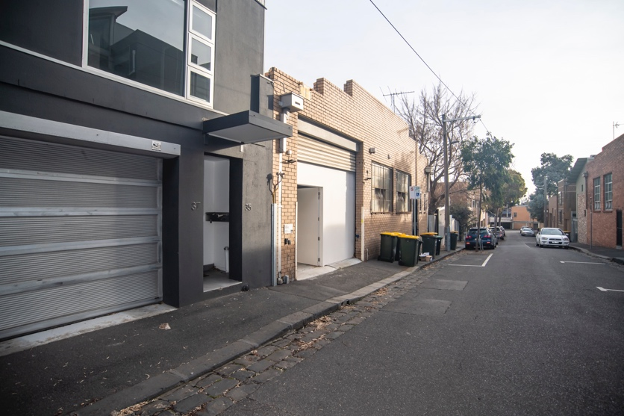
- Additional parking (not specifically reserved for disability badge holders) is available on the surrounding streets.

Step-free entrance to WXYZ Studios at 41 Little Dryburgh Street South

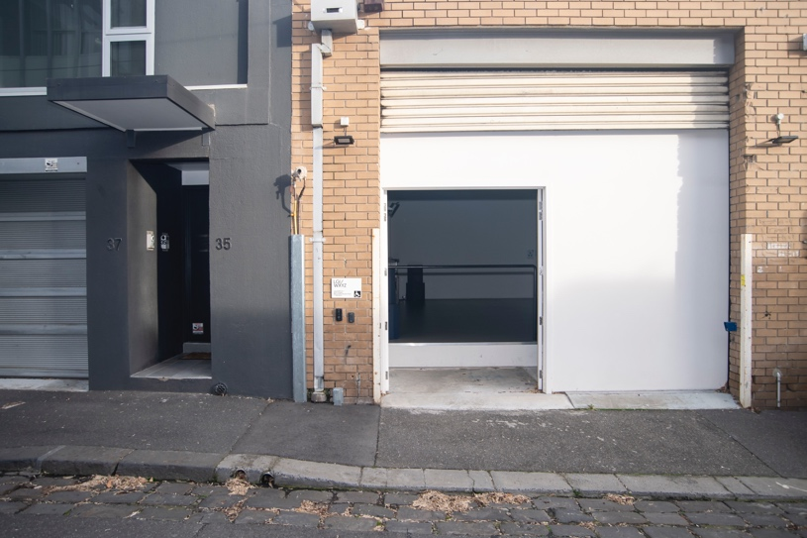
- The access code keypad and intercom at this entrance have been lowered and are positioned 90cm above the ground.

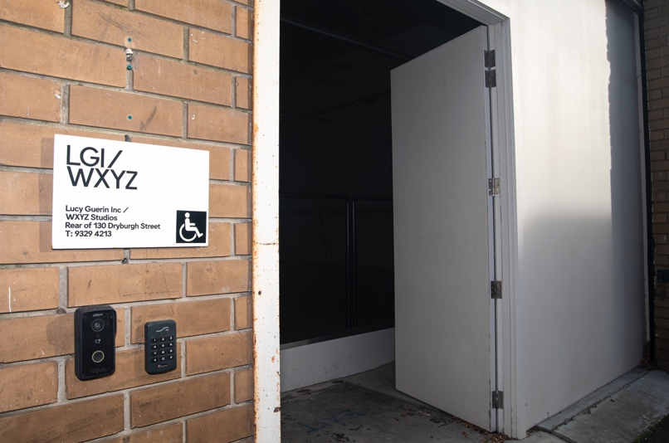
- Please note: The curb cut is bordered by cobblestones and has a lip of around an inch. A temporary ramp is available for use.

Ramped entrance via Studio Two

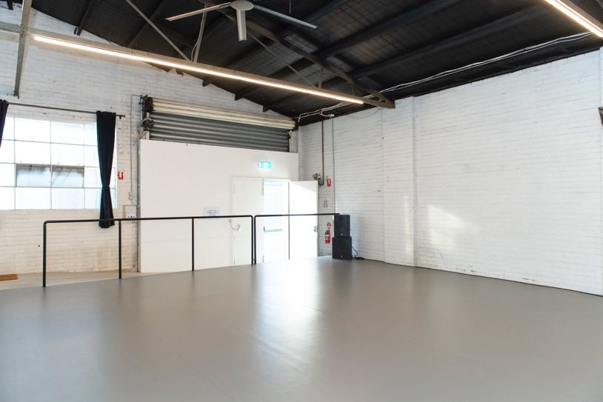
- Ramp gradient = 1:12
- Handrail along length

Ramped entrance to kitchen

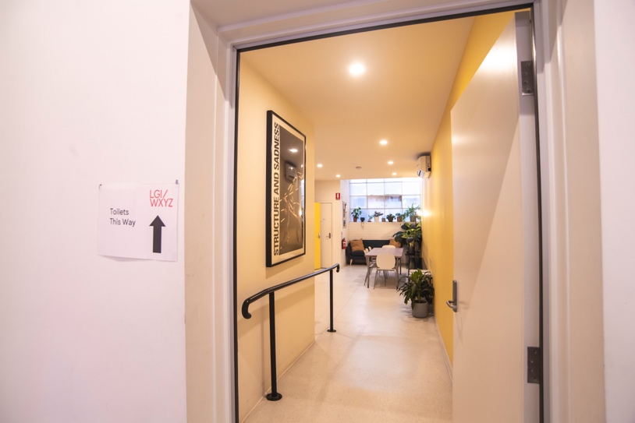
- Ramp gradient = 1:10
- Handrail along length

Accessible bathroom facilities

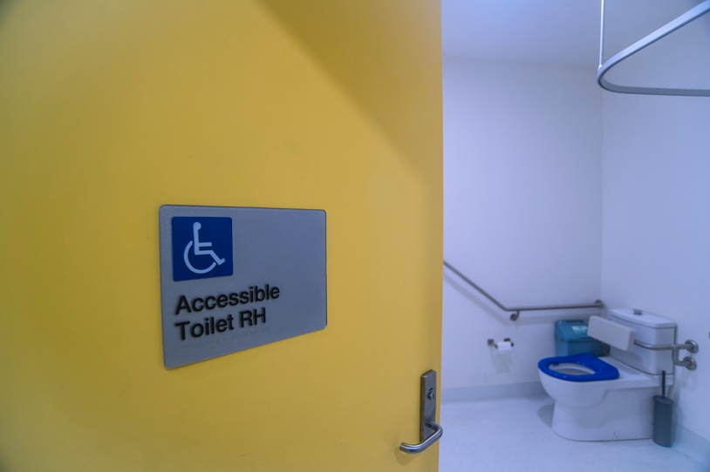
- RH toilet with handrail
- Shower with fold-down bench
- Adjustable shower head with lever-handle
- Lowered sink with lever-handled tap
- Low table for possessions

