A social story visit to WXYZ Studios

What is WXYZ Studios?

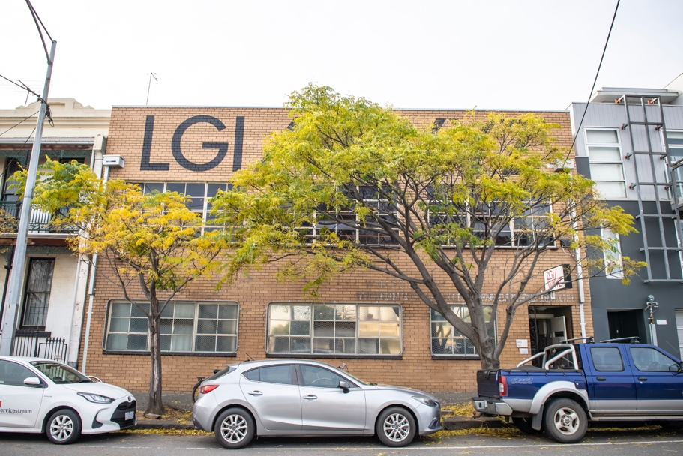
- WXYZ Studios is a red brick building in North Melbourne. Inside are two dance studios and an office.

- It is mainly a place to participate in or watch contemporary dance and is the home of dance company Lucy Guerin Inc.

- But I may also be visiting for another reason, like a workshop, evening class, event or meeting.

Welcome and how we can help?

- The staff at Lucy Guerin Inc are available to support my visit to WXYZ Studios. I understand I can ask them if I need any other information or need assistance.

- I can learn more about who I might meet by downloading the ‘Who are we’ info sheet here: https://lucyguerininc.com/wxyz-studios#accessibility-guide

Arriving at WXYZ Studios
There are two possible entrances to WXYZ Studios:

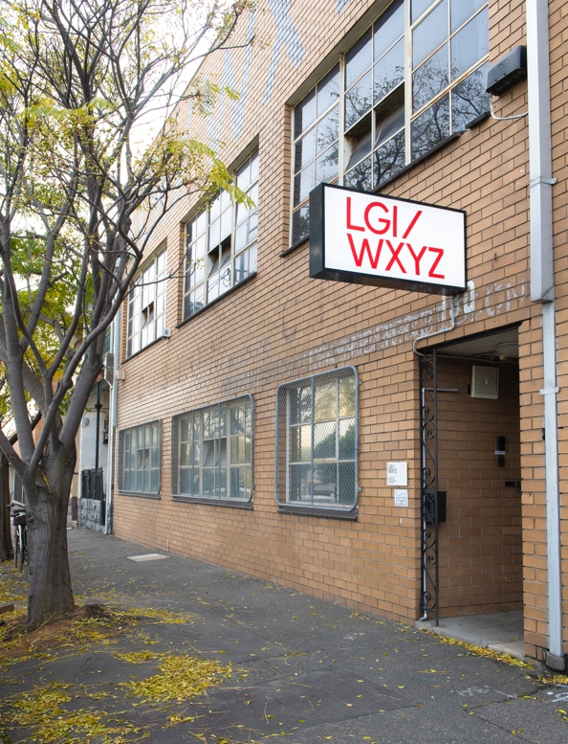
- Office entrance
- This entrance is located at 130 Dryburgh Street, North Melbourne.
- It is a stepped entrance.
- We can provide a temporary ramp for wheelchair access into the Office.

- Dryburgh Street is a busy road with a mix of houses, car repair workshops and warehouses.
- There is a wide pavement and on-street parking.
- WXYZ Studios is about halfway between Victoria Street and Queensbury Street.

- The entry is through a white door, which is in a small porch.
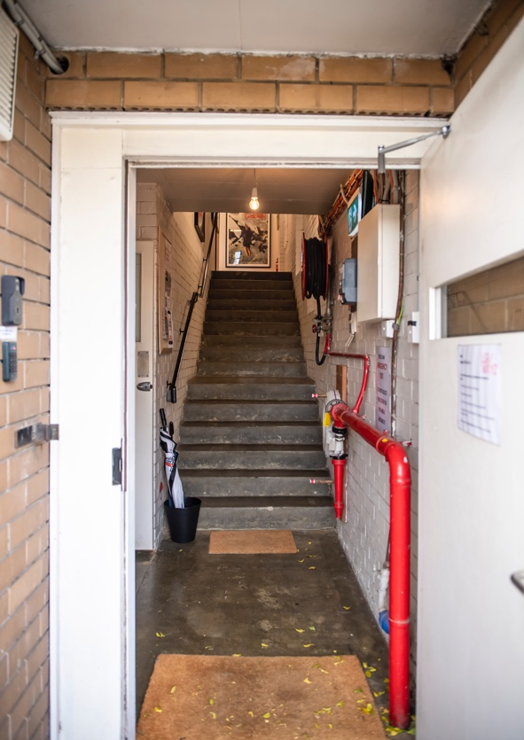
- Above the door is a large white sign with red letters, which I can see from along the street. The sign says LGI/WXYZ.

- To the left of the door is an intercom with one button. It’s 1.5m high. I should press this if the door is closed so someone in the office can unlock the door for me. If I need support opening the door, I can ask them when I hear their voice replying.
- If the intercom is not accessible to me, text a staff member (our mobile numbers are listed in our email signatures).

- Next to the intercom there is a keypad with many numbered buttons. If I’ve been given a code to access the building, I can enter this into the keypad to unlock the door.

- To open to door, I pull it towards me.

- Inside the door there is a short corridor leading to an internal staircase of 16 steps. These steps go up to the two dance studios. On the brick wall there may be posters and notices about activities happening at WXYZ Studios.

- To the left (before the stairs) is another white door leading into a carpeted room with white walls. This is the LGI office where people who work for the dance company may be sat at desks and may say hello to me or ask me if they can help.

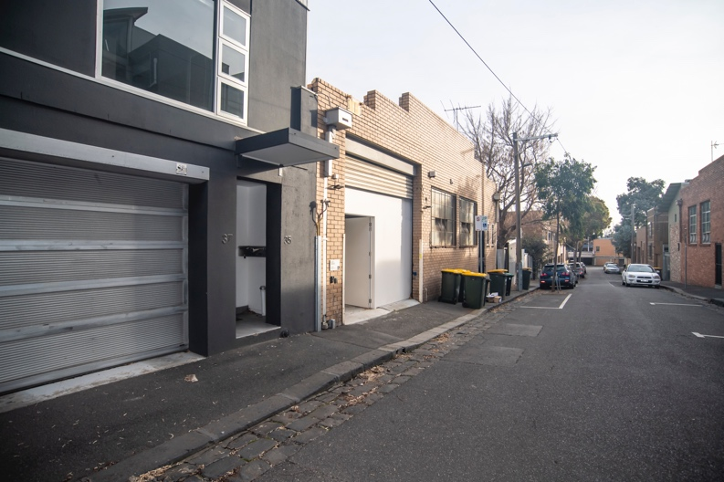
- Step-free entrance to studios
- This entrance is located at 41 Little Dryburgh Street South.
- It is a step-free entrance with a ramp inside the door, the ramp gradient is 1:12.

- There is a curb cut of 5cm from the cobblestones to the pavement.
- If you need a ramp to get over this curb cut, we can provide. Simply call us on 03 9329 4213 and we’ll bring it out.

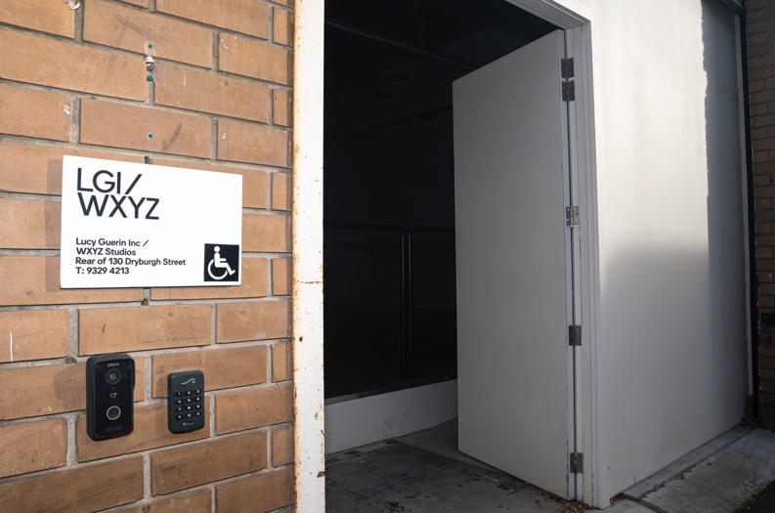
- To the left of the door is an intercom with one button. It’s 90cm high. I should press this if the door is closed so someone in the office can unlock the door for me. If I need support opening the door, I can ask them when I hear their voice replying.

- If the intercom is not accessible to me, text a staff member (our mobile numbers are listed in our email signatures), or call us on 03 9329 4213.

- There is a keypad with many numbered buttons. If I’ve been given a code to access the building, I can enter this to unlock the door.

- To open to door, I push it away from me.

- Little Dryburgh Street South is a quiet cul-de-sac with houses. It has narrow pavements, limited on-street parking and three rows of cobblestones between the road and the curb.

- Inside the door is a large dance studio with white walls and a black metal railing along the ramp leading to a grey vinyl floor. There may be people in this studio who may say hello to me. I understand I can pass through the studio to access the rest of the building.

The Dance Studios
There are two dance studios at WXYZ Studios, called Studio One and Studio Two.

- Studio One
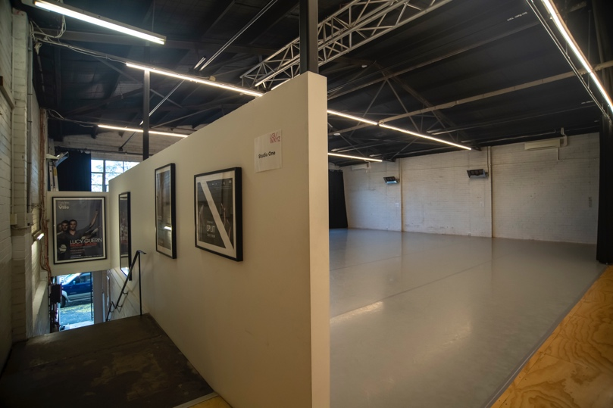
- There is no door into Studio One, I enter from the open corridor.

- There may be black drapes drawn across the corridor, so I should enter where the drapes end.

- This picture shows the entrance into Studio One at the top of the staircase.

- If I have come from the step-free entrance on Little Dryburgh Street South, I enter Studio One via the door in Studio Two.

- Studio Two
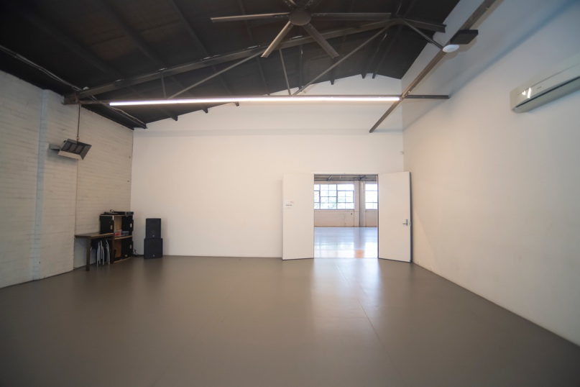
- There are two doors in Studio Two. I can enter from Studio One and or from the step-free entrance from Little Dryburgh Street South.

- This picture shows the view from the top of the ramp from the step-free entrance.

More about the Studios
- Both dance studios have white walls and a high ceiling with thin bars running across with lights on. There’s also a fan in the ceiling which may be turning when I come in to keep the studio cool.

- Both dance studios have grey floors designed for dancing. Removing my shoes helps to protect these floors. If I need to keep my shoes on, I’ll try and clean off any dirt on the door mat first.

- Both dance studios have lots of stools. I can use any of the stools or request a chair with a back and put this anywhere in the dance studio where I’ll need it.

- In the corners of both studios, I’ll find speakers and a sound system. If I’m unsure of how to use this, I understand I can ask someone from the dance company for help.

- Both studios have large black curtains known as theatre drapes. These may be covering the windows or tucked in the corner when I arrive. They allow us to make the room darker private if that’s better for the work we are doing.

- There is another row of large black curtains between the two studios. Drawing them makes Studio One into a more private space.

- There are white double-doors that connect the two studios. If I’m going into Studio Two and these doors are closed, I understand to knock first as people may be working in there. There may be other instructions written on the door and I should follow these (such as entering and waving to get the attention of a Deaf artist).

- If I’m coming to WXYZ Studios for a performance, talk or other event, the studios may look a little different. For example, there may be more lights or chairs set out. If I’m concerned about this, I understand I can contact the dance company and ask them to describe or send me an image of what the studios may look like.

The Kitchen
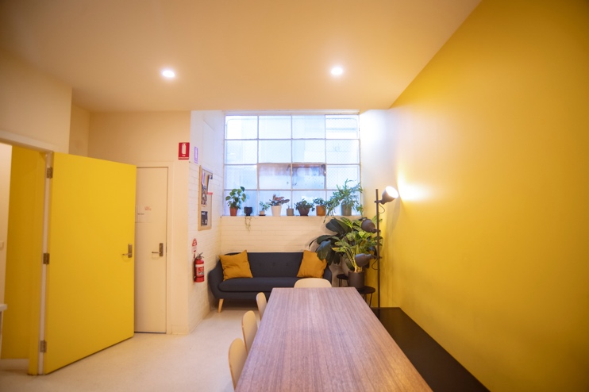
- The kitchen has one yellow wall, a table with white chairs and a black bench, grey kitchen cabinets with various appliances and a sink and a large white fridge.

- This picture shows the view as you enter into the kitchen from the dance studios.

- The kitchen is a shared space, so there may be other people in here or who come and go during my visit. All are welcome to use this space to socialise, prepare food, and eat and drink.

- There are three doors in the kitchen:
- At the top of the ramp, there is a white door I use to access the studios, to go downstairs to the office, or to use either of the exits.
- Next to the kitchen cabinets is a yellow door that I use to go into the changing room, toilets and accessible bathroom.
- Next to table is a white door with a sign that reads ‘no exit’ and should not be opened.

- Kitchen facilities:
- Table and chairs: I can rearrange these as I need to allow access for everyone in my group.
- Paper and pens: These are on the small table next to the sofa. I can use them to help me communicate better with other people.
- Sofa: There is a blue sofa in the kitchen which I’m welcome to sit on.
- Fridge: The fridge door opens from the right side.
- Kettle and microwave: On the grey cabinets are a kettle for boiling water and a microwave for heating food. I understand I can ask for support using these from the dance company staff.
- Dishwasher: To the left of the sink is a dishwasher in a grey cupboard that opens from the top. I understand to put any plates, cups, or utensils I’ve used in here so they can be cleaned.
- Bins: There are two bins. One is for recycling and the other is for general waste. If I’m unsure which bin to use, I understand I should use the general waste bin.
Changing room, toilets and accessible bathroom

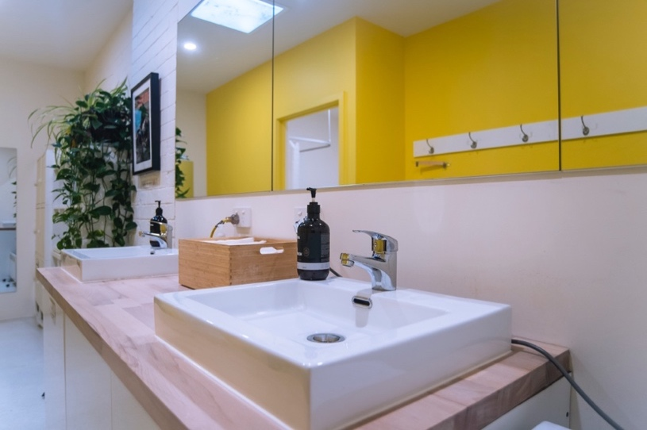
- The changing room has a changing area, two sinks, two toilets and a shower. There is also an accessible bathroom with a toilet, sink and shower.

- This picture shows the view from the entrance into the changing room.

- I understand the changing room is a shared space and are ‘all gendered’, which means people from all genders can change in this room. I understand if I would like to change in private, I can use the accessible bathroom.

- I enter the changing room from the kitchen through the yellow door.

- There are white shelves and lockers where I can place my possessions, as well as hooks over the black bench where I can hang my clothes. I understand I should keep valuable possessions with me.

- There are two sinks. In between the sinks is a wooden box with paper towels in it. When I’ve used a paper towel, I understand to put it in the black bin near the entrance.

- There is a shower behind a sliding white door, which is in front of me as I enter the changing room. I should bring a towel with me if I want to use the shower and should dry off before re-entering the changing room.

- There are two toilets that are not wheelchair accessible, but the toilet on the left has a handrail.

Accessible Bathroom (RH)
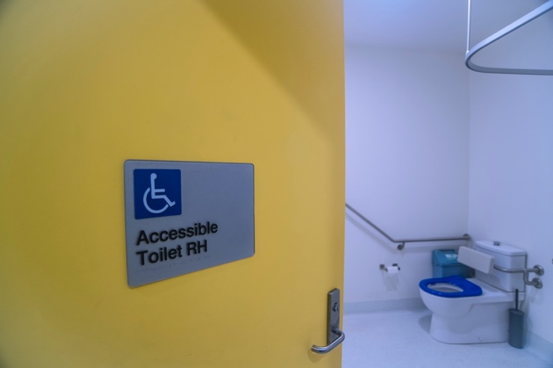
- The accessible bathroom is at the end of the change rooms. I push the door to open it and can lock it from the inside.

- This bathroom has:
- RH toilet with handrail.
- Sink at a lower height with a lever tap.
- Low round table for possessions.
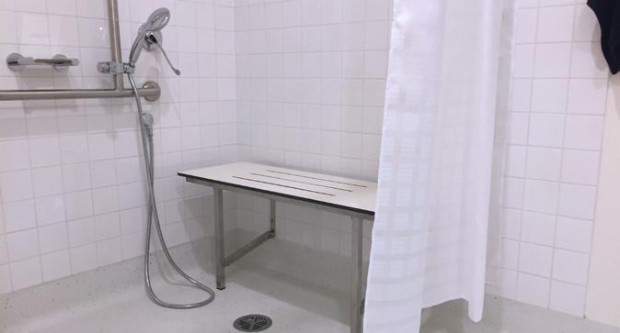
- Shower with an adjustable shower head and lever handle.

- Fold-down shower bench.

- I should bring a towel with me if I want to use the shower and should dry off before re-entering the changing room.

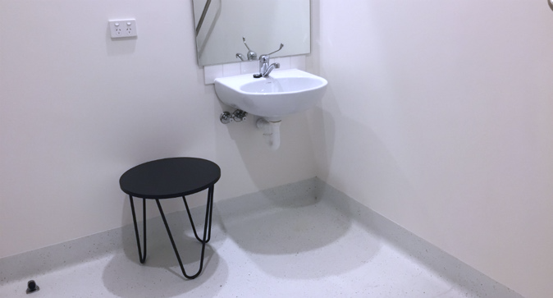

LGI Office
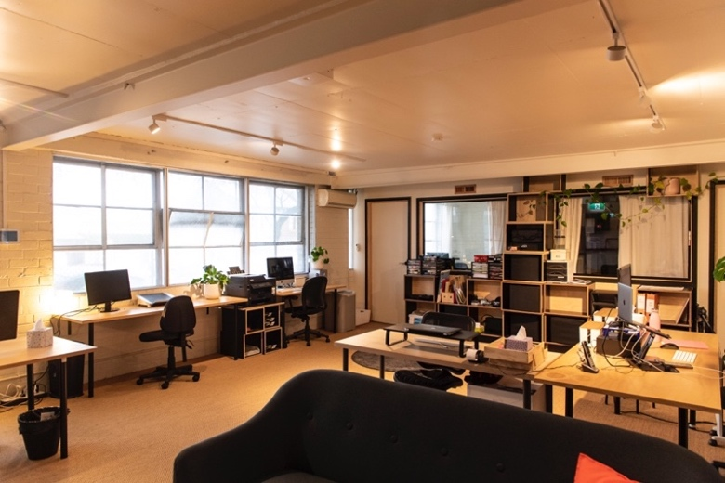
- The office is located downstairs next to the office entrance on Dryburgh Street.
- It has tables, chairs and sofas as well as office equipment like computer screens.
- This picture shows the view from corner of the office.

- I enter the office through a white door, which may already be open.

- In the office I may meet LGI staff members who may ask how they can help during my visit, and I should feel welcome to tell them anything I may need during my visit.

