Visual Story

A visit to WXYZ Studios: stepped entrance to dance studios and step-free entrance to office.

WXYZ Studios is a red brick building in North Melbourne. Inside are two dance studios and an office.

The stepped entrance to dance studios and a step-free entrance to the office is located at 130 Dryburgh Street.

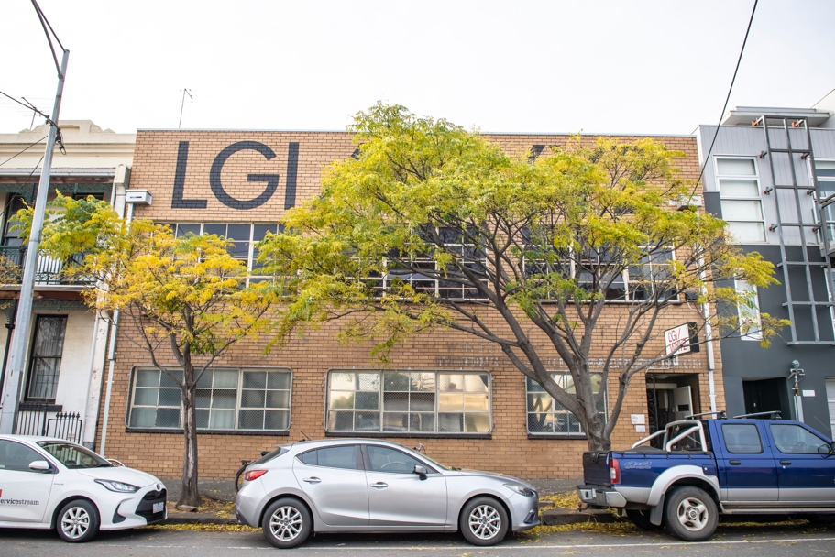

This is the sign above the front door.
The front door may be closed or open and there is a single small step in front of it.

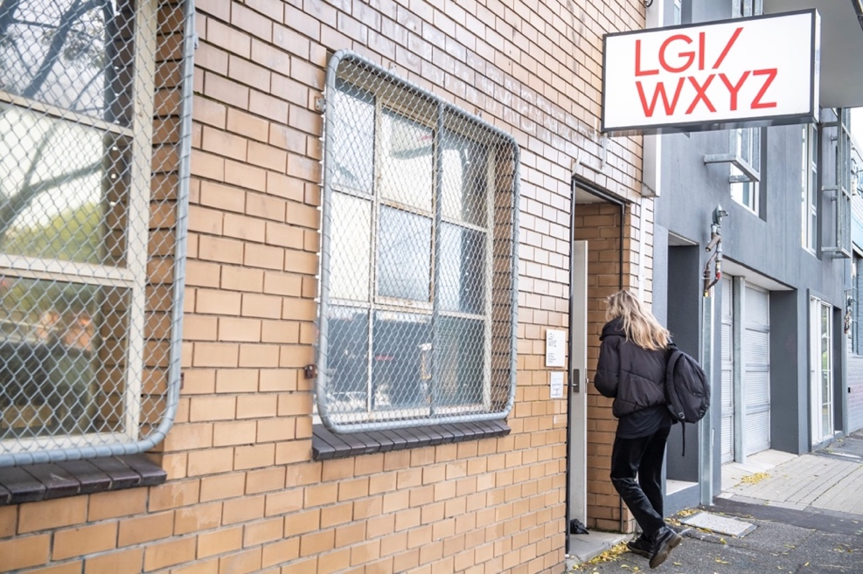

We can provide a temporary ramp for wheelchair access into the office. Simply call us on 03 9329 4213 and we’ll bring it out.

This is the intercom (top) and the keypad (bottom).
To use the intercom, press the black button to speak to the LGI office
Use the keypad to enter your access code if you have one — such as 1234*

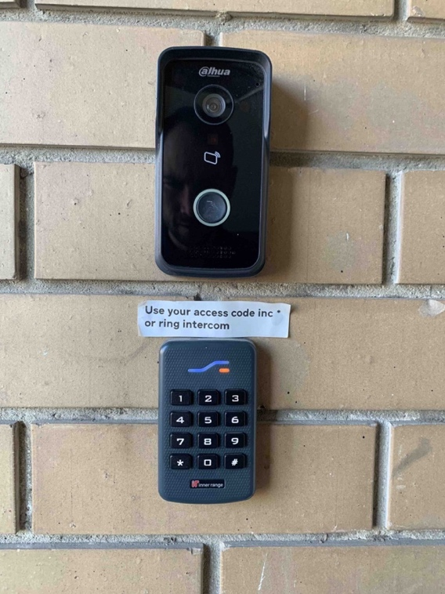

These are the stairs leading up to the studios from Dryburgh Street—there are 16 steps.

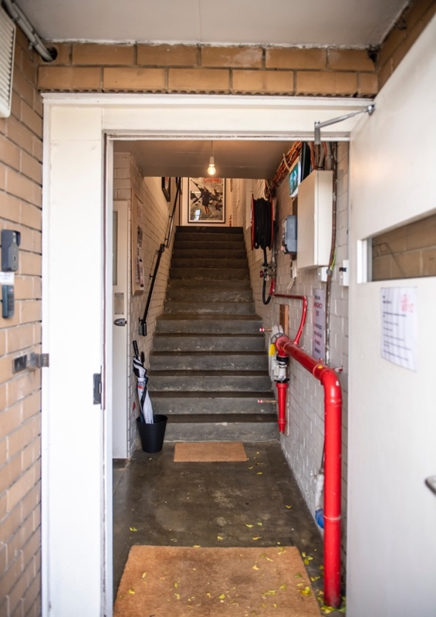

This is the LGI office.
If people are in the office, come in and say hello. This is a good opportunity to ask questions about your visit.
If you are unsure which studio your activity is in, the staff will be able to help show you.

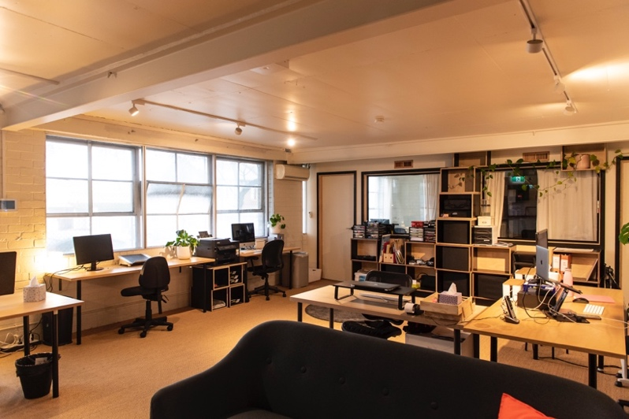

This is the view of Studio One from the top of the stairs. It is the larger studio.
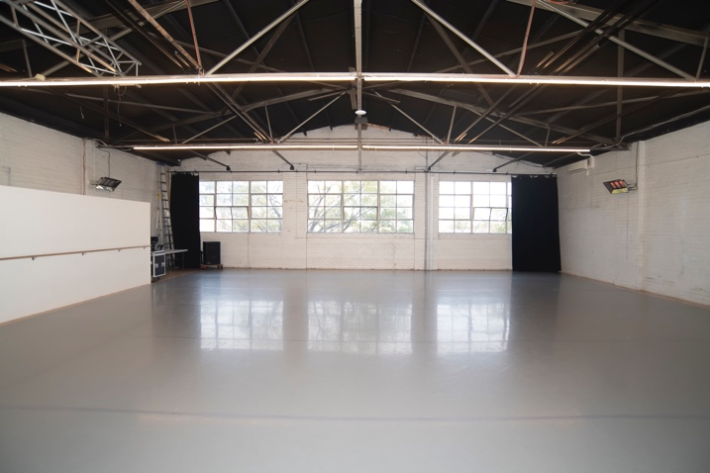
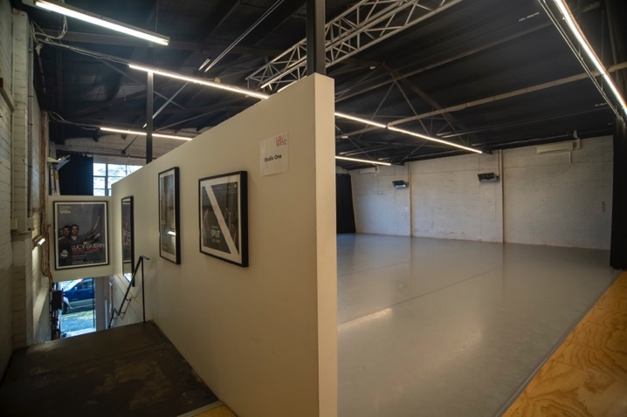

Sometimes the black drapes are closed, and it looks like this.

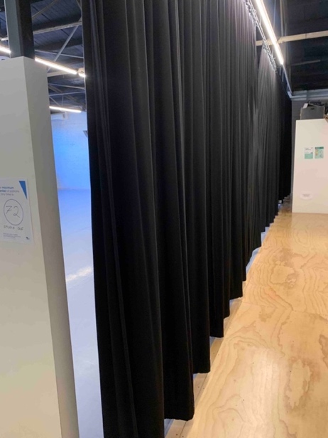

This is the entrance to Studio Two. If the door is closed, knock before entering.

This is Studio Two. It is the smaller studio. The step-free entrance / exit is behind you.

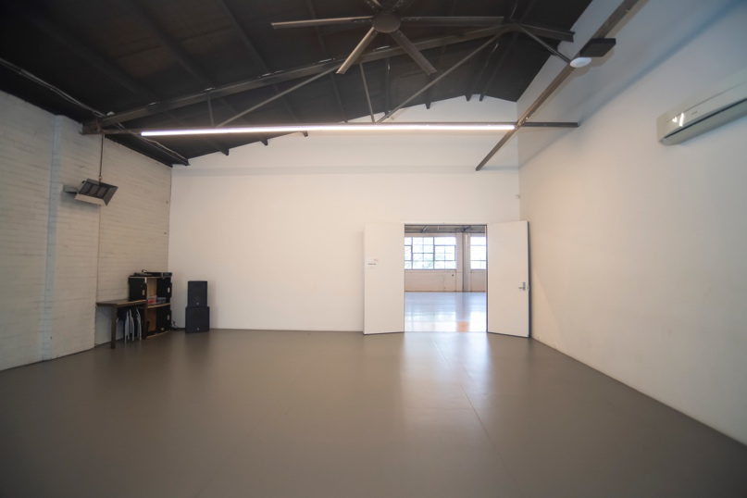

The kitchen door is next to the door into Studio Two. It has a ramped entrance and handrail on the left.

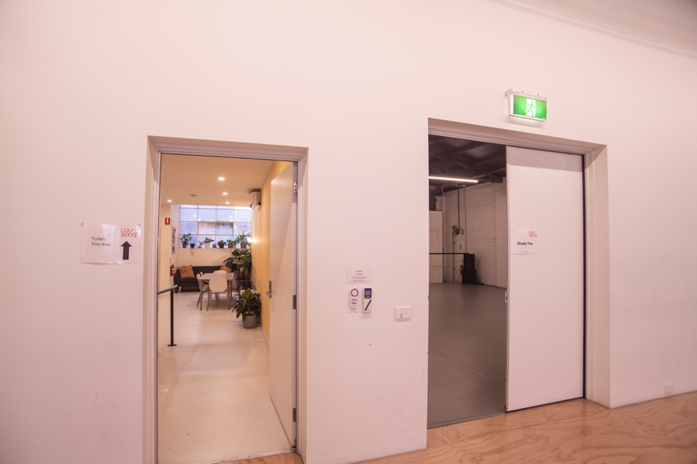

This is the kitchen. There is a large fridge, dishwasher, sink with taps, coffee machine, kettle, and microwave.

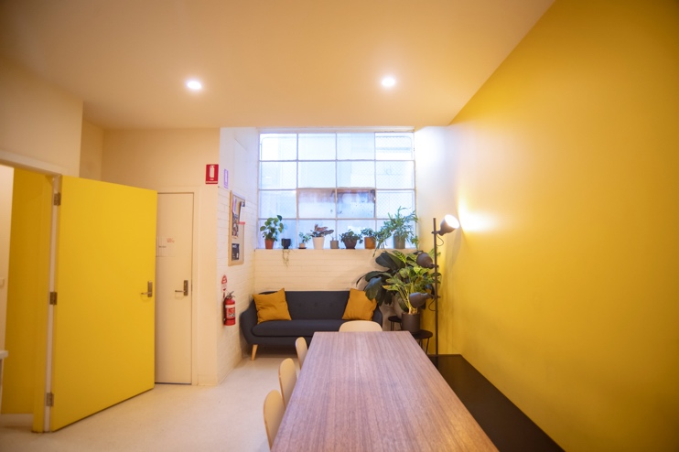

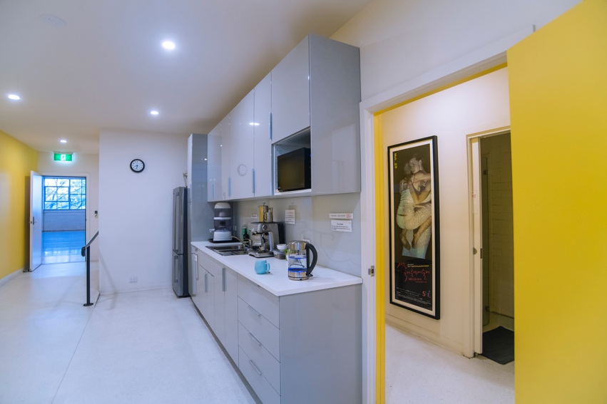

The changing rooms and bathrooms are next to the kitchen.
There are hooks to hang clothes and pigeonholes and lockers where you can put your things.
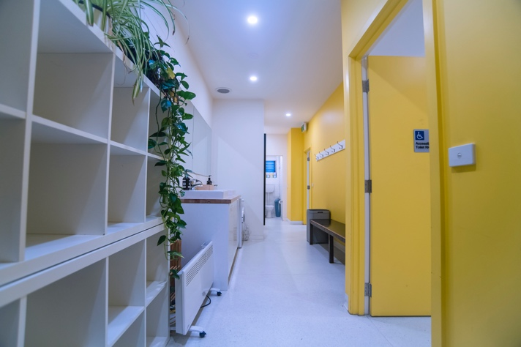
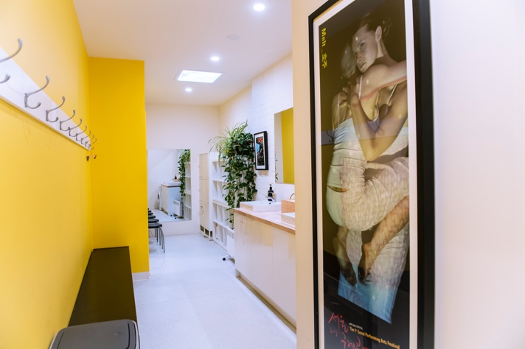
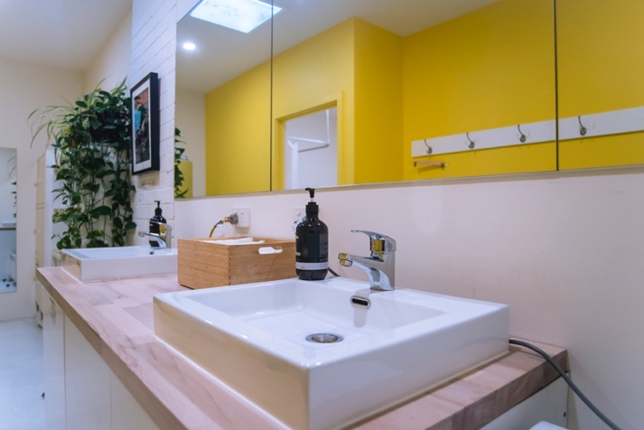
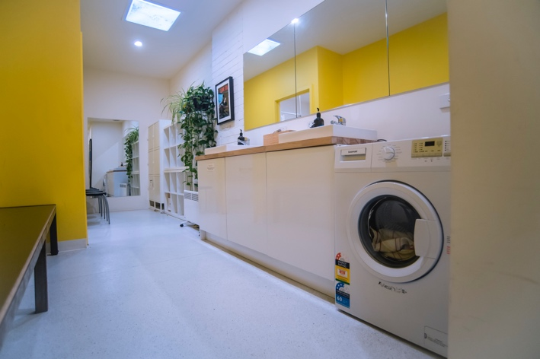

These are the doors to two toilets.
The one on the left has a handrail inside.

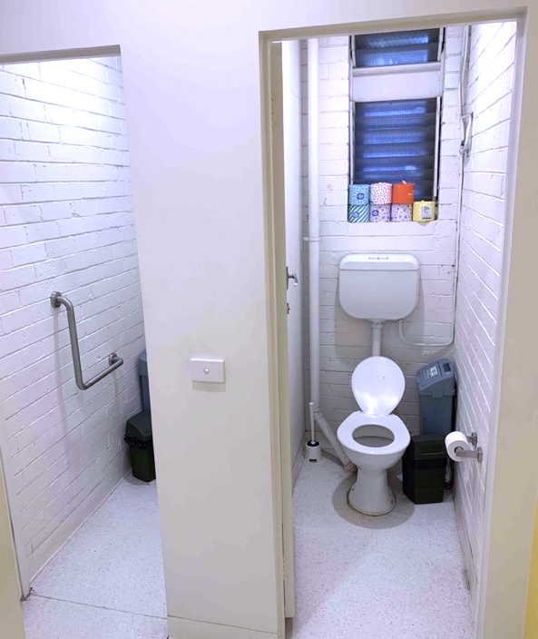

This is the door to the accessible bathroom.

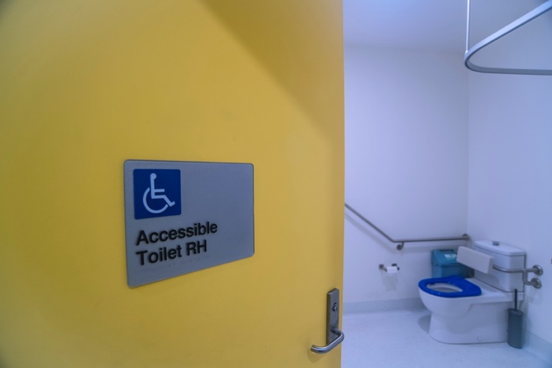

The accessible bathroom has a RH toilet with handrail, a shower with fold-down bench and a sink with lever-handled tap.
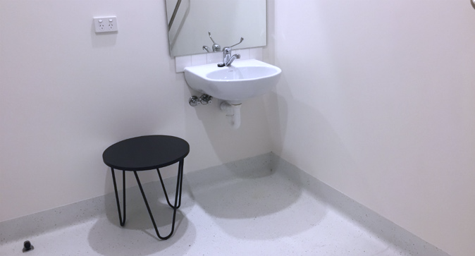
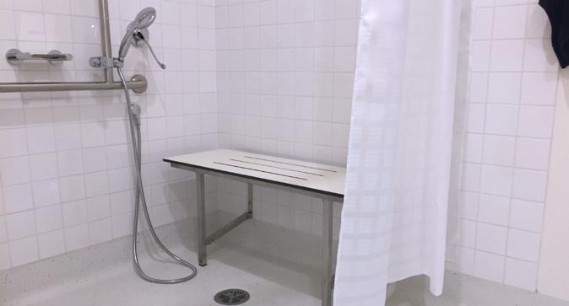
At the end of your visit, you may leave via the same door you entered.
Follow the wooden floor in Studio One to find the stairs which lead to the exit. Push the door handle down to exit onto Dryburgh Street.

